# Task 9:

**Aim:** Toperform record play back using Selenium IDE Script.

# Description:

The entire script creation process can be classified into 3 chunks:

**Process 1: Recording** – Selenium IDE aids the user to record user interactions with the browser and thus the recorded actions as a whole are termed as Selenium IDE script.

**Process 2: Playing back** – In this section, we execute the recorded script so as to verify and monitor its stability and success rate.

**Process 3: Saving** – Once we have recorded a stable script, we may want to save it for future runs and regressions.

# Procedure:

**Steps:**

* Open Google Chrome search for Selenium IDE.

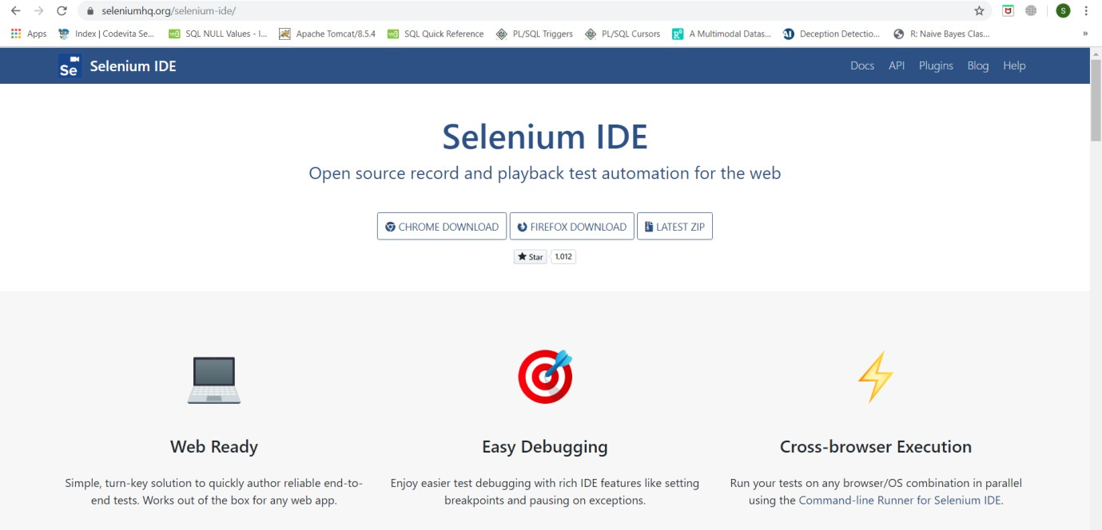

* Click on CHROME DOWNLOAD.
* Click on Add to Chrome.

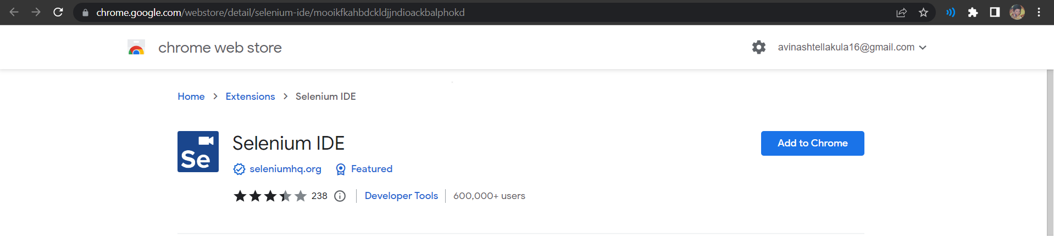

* Click on Add Extension.

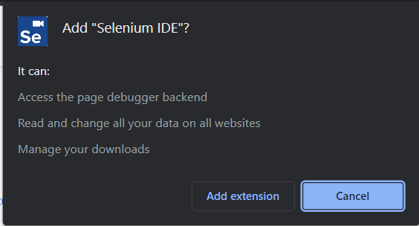

* Click on Selenium IDE Add-on.



* Click Record a new test in a new project.

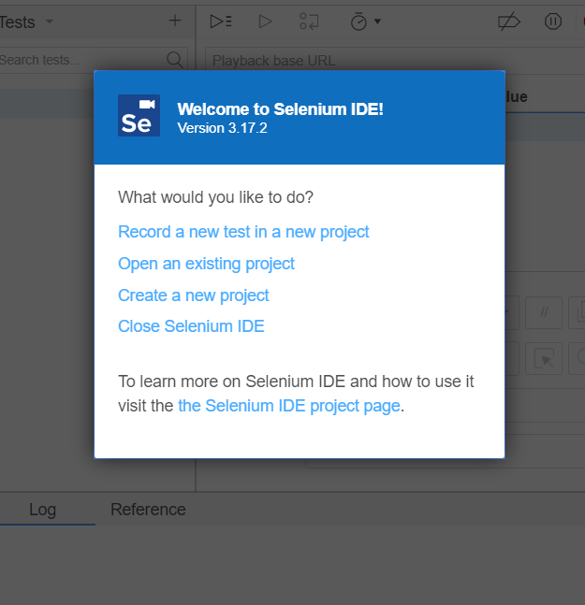

* Enter Project Name and click ok.

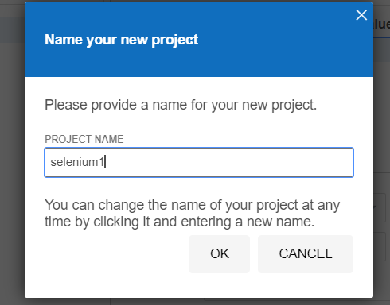

* Enter Base URL for Mortgage Calculator and click START RECORDING.

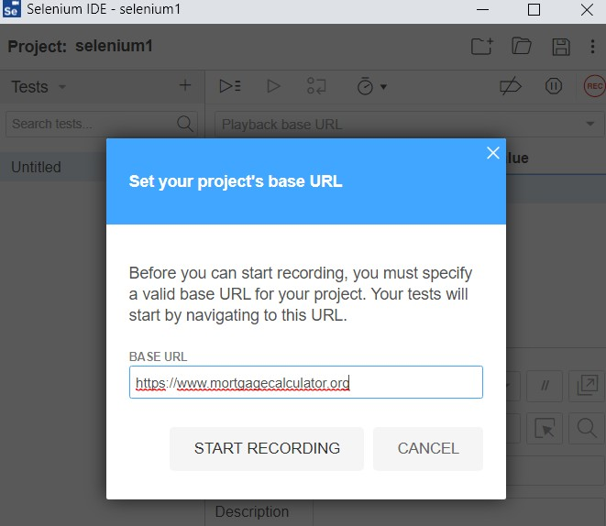

* It opens Mortgage Calculator home page. It will show the message Selenium IDE is Recording. Perform some action (like scrolling down the page, clicking on something etc) in that page for few seconds. This action will be recorded by Selenium IDE.

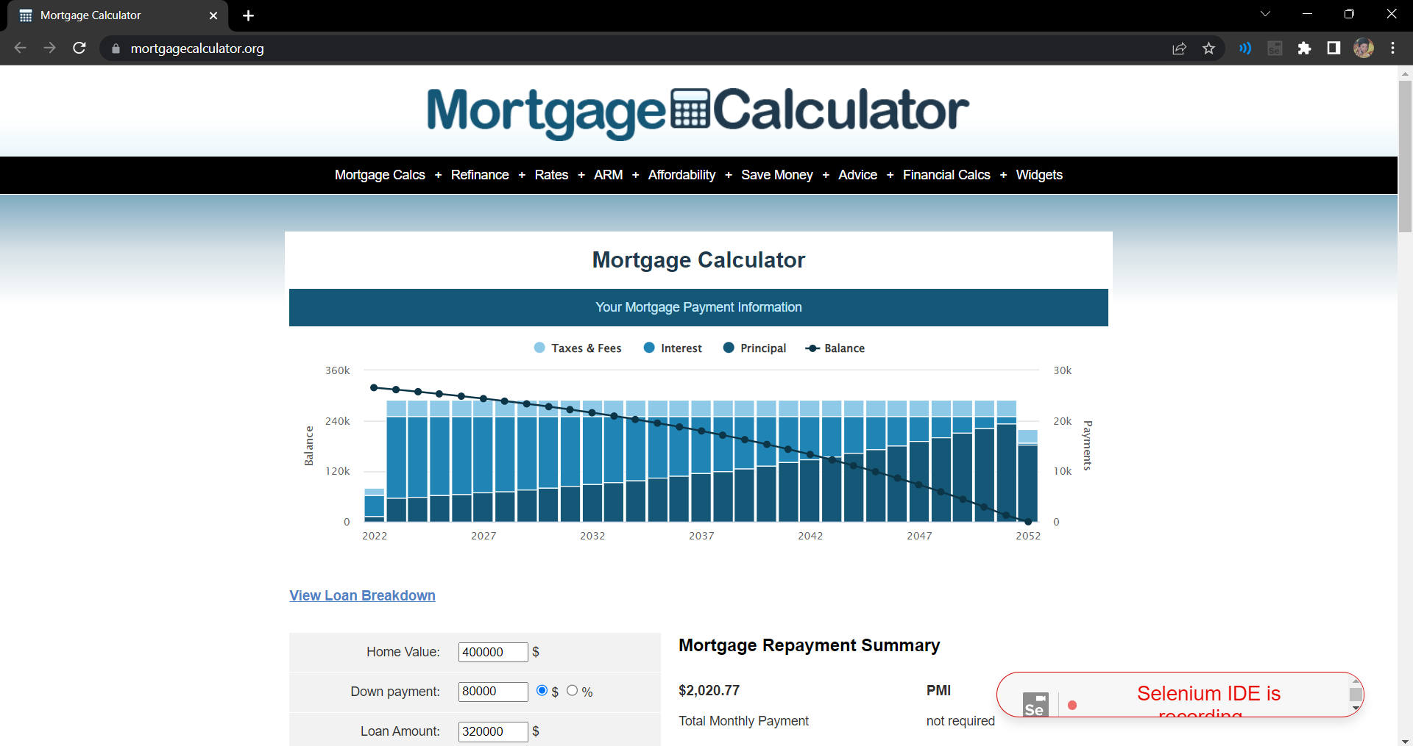

* Now pause the recording by clicking on the pause symbol present at right side of selenium IDE



* Enter TEST NAME and click OK.

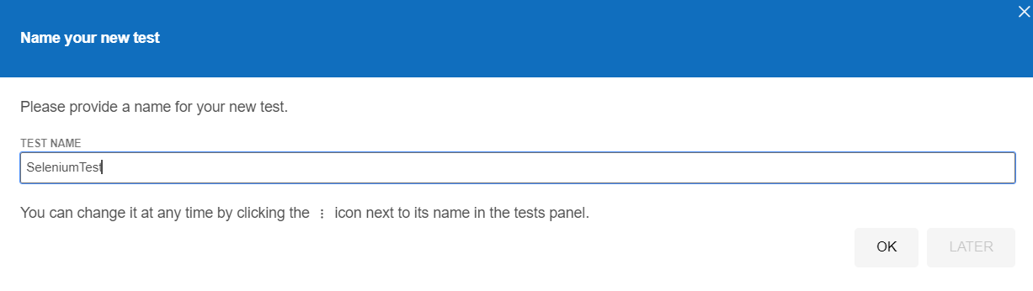

* 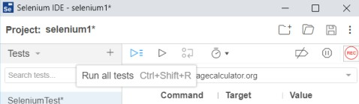Click on Run all Test Cases. It will open Mortgage Calculator and shows the actions performed by you previously.

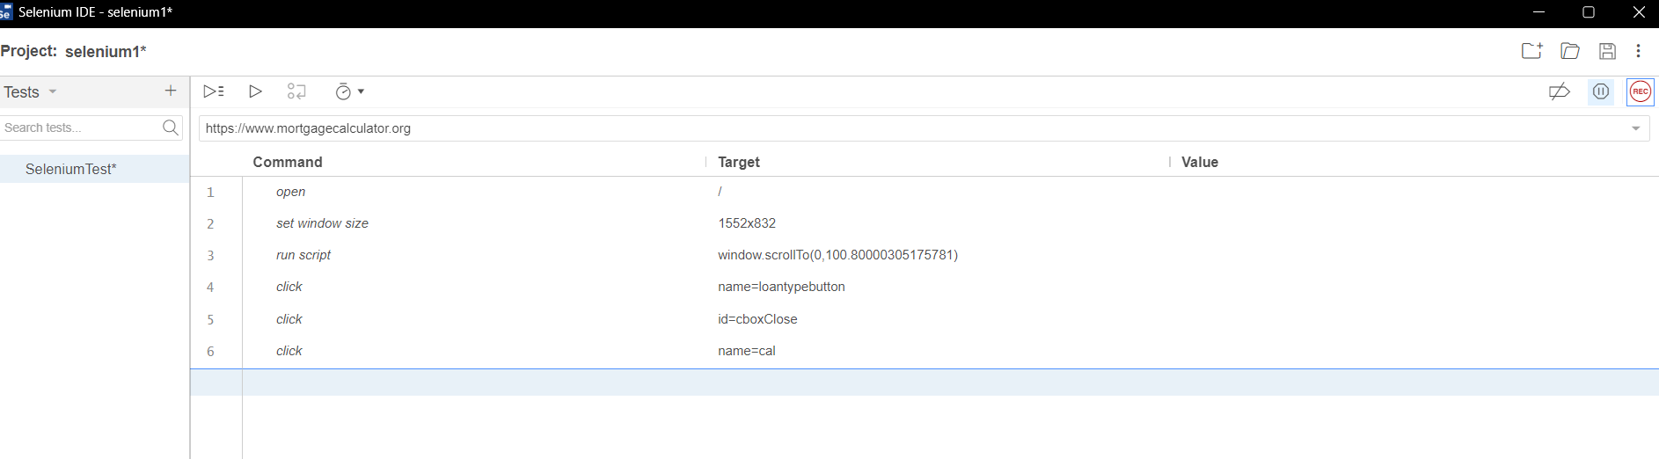

* It shows message ‘SeleniumTest completed successfully’.

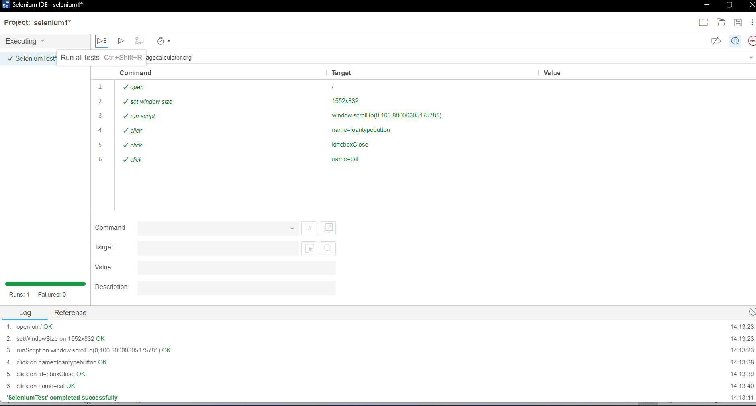

* Click save icon give name to the file click save button It is saved with .side extension. Right click on that .side file click edit with notepad Copy the script present in it.This script shows what you have recorded. This script is shown as follows.

{

"id": "38cf2dee-9102-41ec-bff8-e611e5dac0df",

"version": "2.0",

"name": "selenium1",

"url": "https://www.mortgagecalculator.org",

"tests": [{

"id": "abf4559b-c7c3-4bac-8119-58a1d18604a4",

"name": "SeleniumTest",

"commands": [{

"id": "4d4359ee-7046-4a6f-b14b-221809321223",

"comment": "",

"command": "open",

"target": "/",

"targets": [],

"value": ""

}, {

"id": "c0a31e29-ec36-4c2e-b2b5-338a978341ed",

"comment": "",

"command": "setWindowSize",

"target": "1552x832",

"targets": [],

"value": ""

}, {

"id": "8314606e-3bbc-4125-afb6-5e6a1783ed10",

"comment": "",

"command": "runScript",

"target": "window.scrollTo(0,100.80000305175781)",

"targets": [],

"value": ""

}, {

"id": "b3023467-1b21-4ea9-a3f7-a8064a23b993",

"comment": "",

"command": "click",

"target": "name=loantypebutton",

"targets": [

["name=loantypebutton", "name"],

["css=.example12 > .styled-button", "css:finder"],

["xpath=//input[@name='loantypebutton']", "xpath:attributes"],

["xpath=//div[@id='calc']/form/section/section[2]/div/div/div/div/div/div[4]/div/div/div[14]/a/input", "xpath:idRelative"],

["xpath=//div[14]/a/input", "xpath:position"]

],

"value": ""

}, {

"id": "7049727c-5110-4c01-b761-9e3435b5625d",

"comment": "",

"command": "click",

"target": "id=cboxClose",

"targets": [

["id=cboxClose", "id"],

["css=#cboxClose", "css:finder"],

["xpath=//button[@id='cboxClose']", "xpath:attributes"],

["xpath=//div[@id='cboxContent']/button[4]", "xpath:idRelative"],

["xpath=//button[4]", "xpath:position"],

["xpath=//button[contains(.,'close')]", "xpath:innerText"]

],

"value": ""

}, {

"id": "6d6be8f3-4519-4c76-8e1a-ca9517339b28",

"comment": "",

"command": "click",

"target": "name=cal",

"targets": [

["name=cal", "name"],

["css=.rw-box > .styled-button", "css:finder"],

["xpath=//input[@name='cal']", "xpath:attributes"],

["xpath=//div[@id='calc']/form/section/section[2]/div/div/div/div/div/div[4]/div/div/div[17]/input", "xpath:idRelative"],

["xpath=//div[17]/input", "xpath:position"]

],

"value": ""

}]

}],

"suites": [{

"id": "3d08c647-6f0d-45f0-a59b-5c61d3ad1c3f",

"name": "Default Suite",

"persistSession": false,

"parallel": false,

"timeout": 300,

"tests": ["abf4559b-c7c3-4bac-8119-58a1d18604a4"]

}],

"urls": ["https://www.mortgagecalculator.org/"],

"plugins": []

}

# Result:

Thus,performing record play back using Selenium IDE Script has been performed successfully

**Evaluator’s Observation**

**Marks Secured: out of**

**Full Name of the Evaluator: Student’s Signature**

**Signature of the Evaluator: Date of Evaluation:**

# Task 10:

**Aim:** Identify Web elements using Id, Name and XPath using Selenium IDE.

# Steps:

1. Search firebug for chrome click firebug lite for chrome.

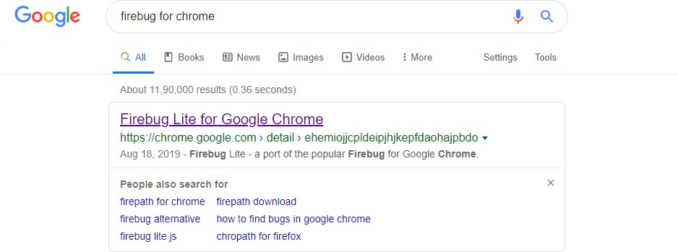

1. Click add to chrome.

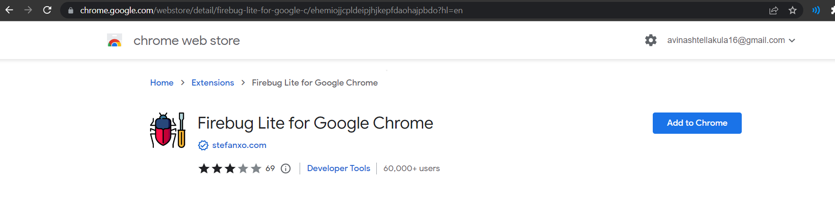

1. Click add extension.

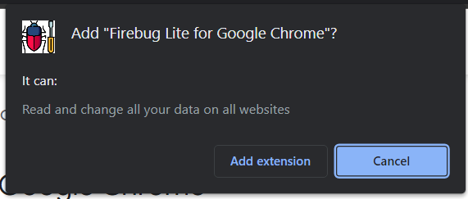

1. Openfacebook home page.

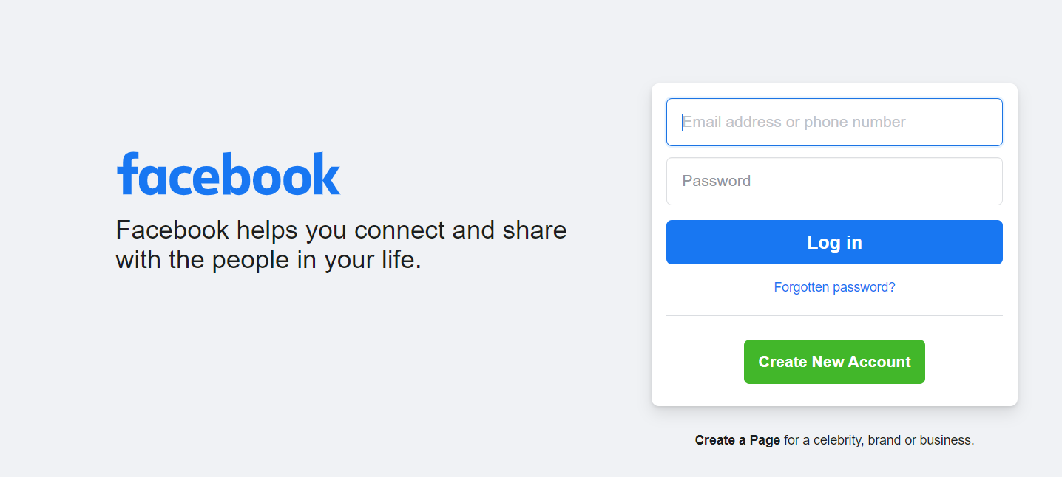

1. Click on firebug.

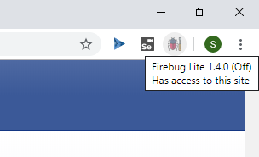

1. Click ok.

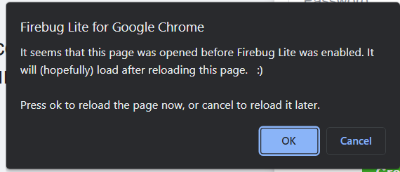

1. Click on fire bug again. It will open console below.



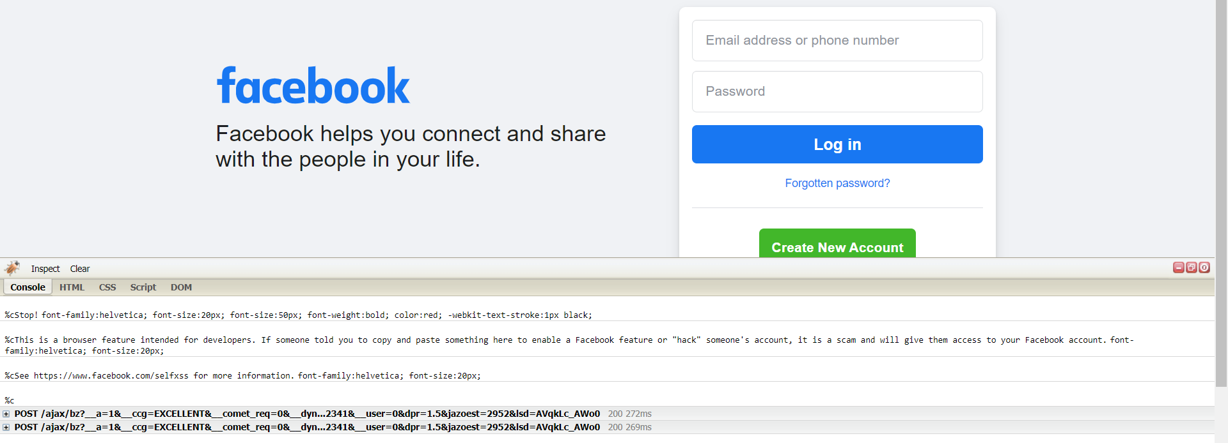

1. Click on inspect button.



Hover on the required element present on facebook login page, then we will get Class, Id corresponding to that element.

# Identifying Web elements using Id using Selenium IDE:

* 1. Hover on Email or Phone text box field to get its details and copy its ID field from the code.

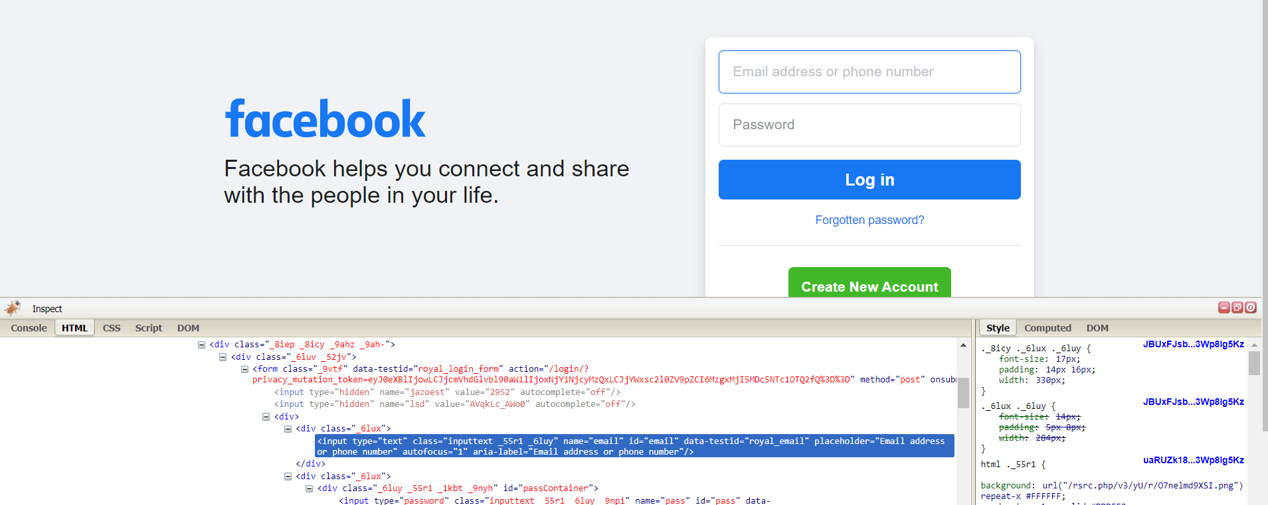

* 1. Click on selenium and click record a new test in a new project.

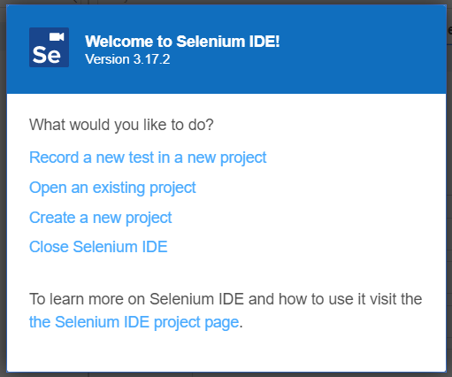

* 1. Name your project Give Facebook home page URL and click Start Recording.

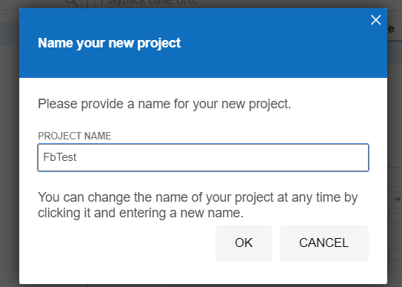

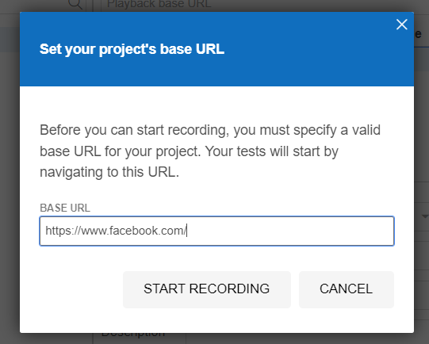

* 1. Selenium opens the given url and starts recording the action you will be performing in that page.

(Note: Don’t close that facebook page opened by selenium IDE) Now minimize Facebook page.

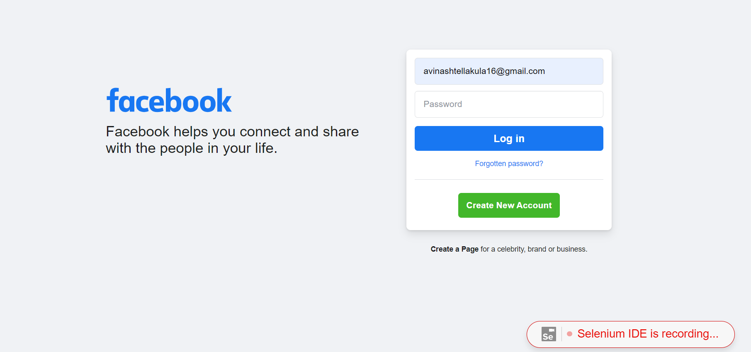

* 1. Click stop recording Give Test Name and click OK.

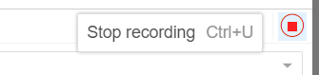

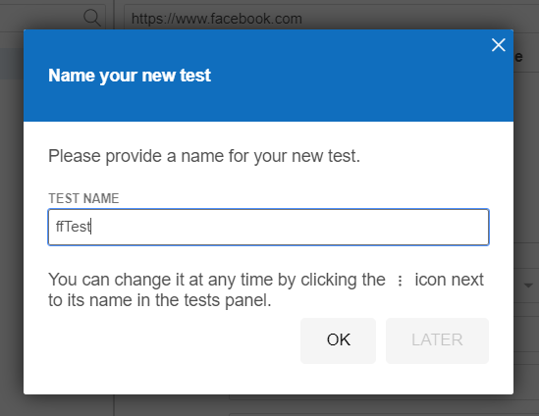

* 1. In command field, give **verify selected value** and in target give **id=email**.

(Note: email is the ID value for email field present in facebook login page which was copied before).

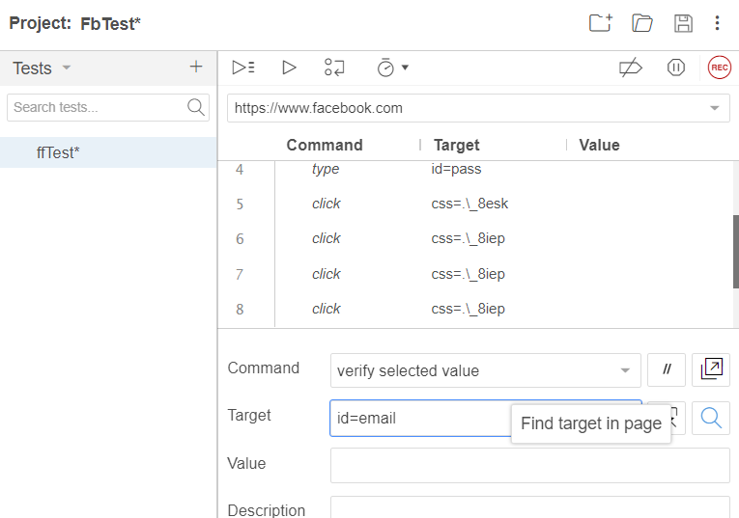

* 1. Now click on search button beside target field. Now, email field will blink.

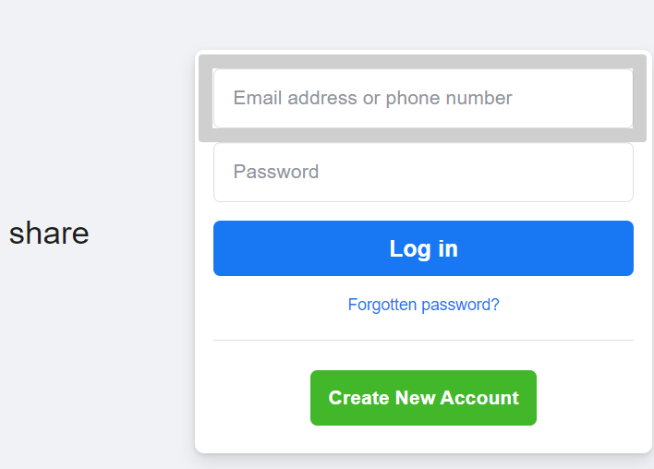

# Identifying Web elements using Name using Selenium IDE:

1. Now inspect and copy **name** field value for Email or Phone field.

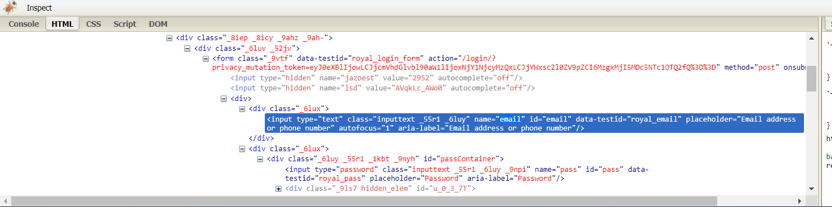

1. In command field, give **verify selected value** and in target give **name=email.**
2. (Note: **email** is the name value for email field present in facebook home page which was copied before).

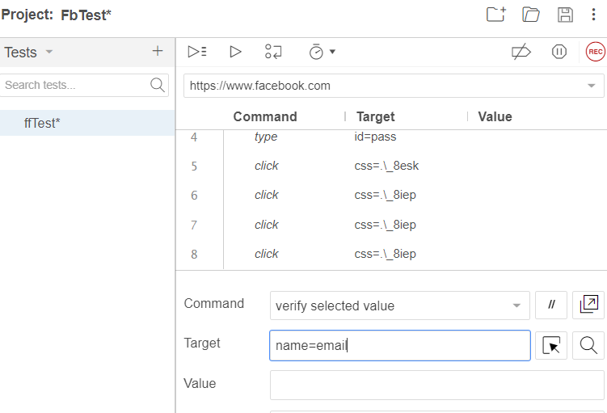

1. Now click on search button beside target field. Now, email field will blink.

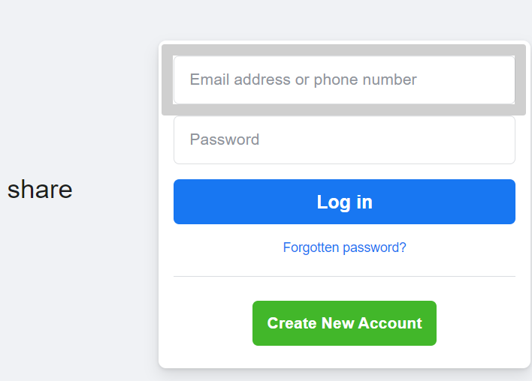

# Identifying Web elements using XPATH using Selenium IDE:

1. Open facebook home page in chrome Right click click inspect.

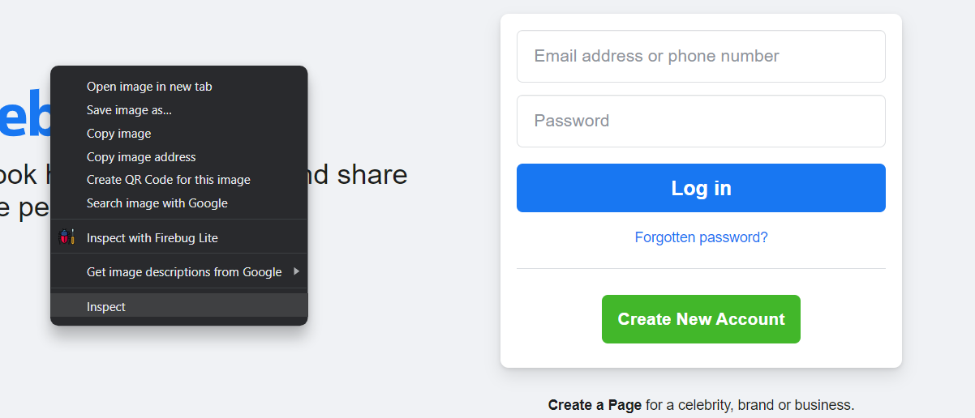

1. Click inspect element select **Create a new account** element to inspect.



1. Right click on the tag for **Create a new account** copy copyXPath.

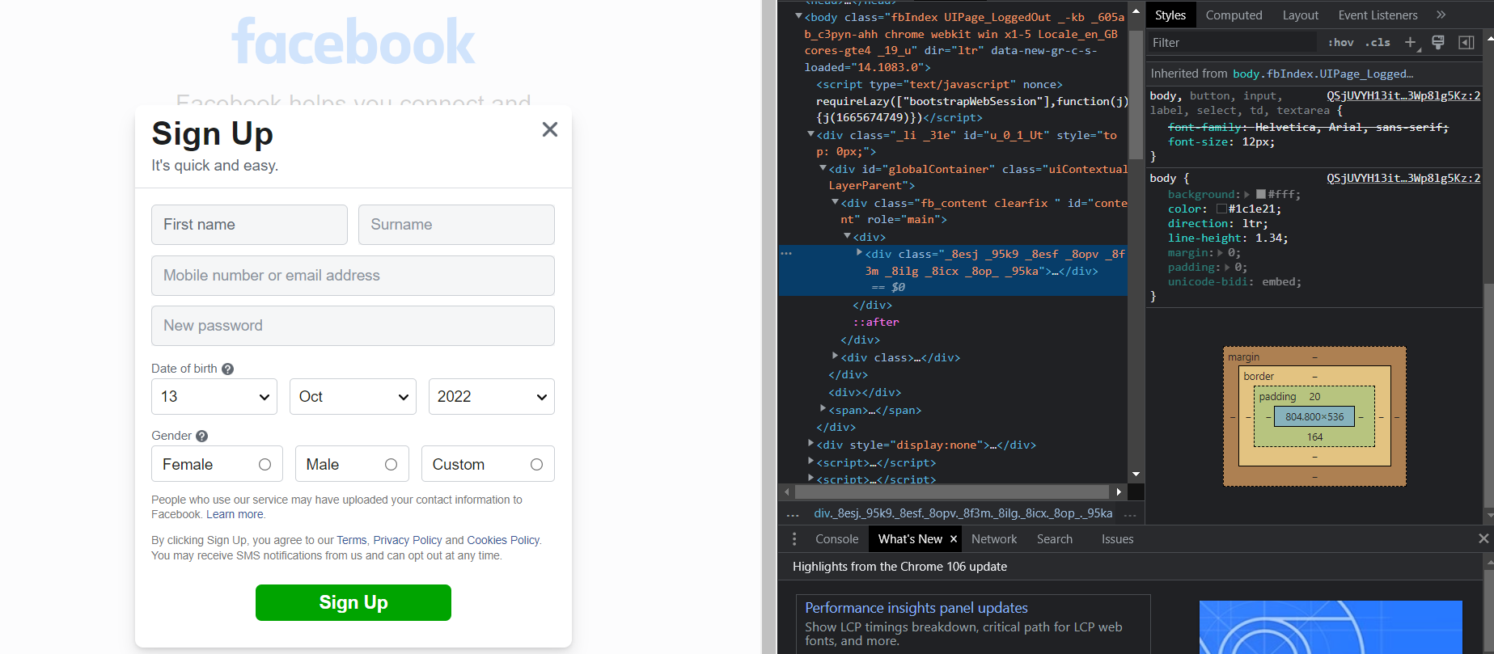

1. Now go to console tab give following command.

# $x(‘//*[@id="content"]/div/div/div[1]/div[1]’)

(Note: //*[@id="content"]/div/div/div[1]/div[1] is the XPath )

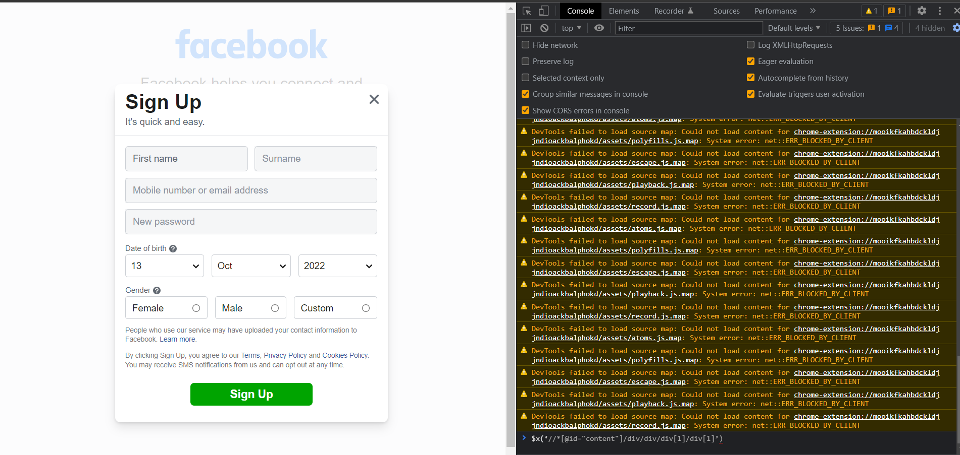

1. Now click the dropdown and hover on the command **Create a new account** field gets selected.

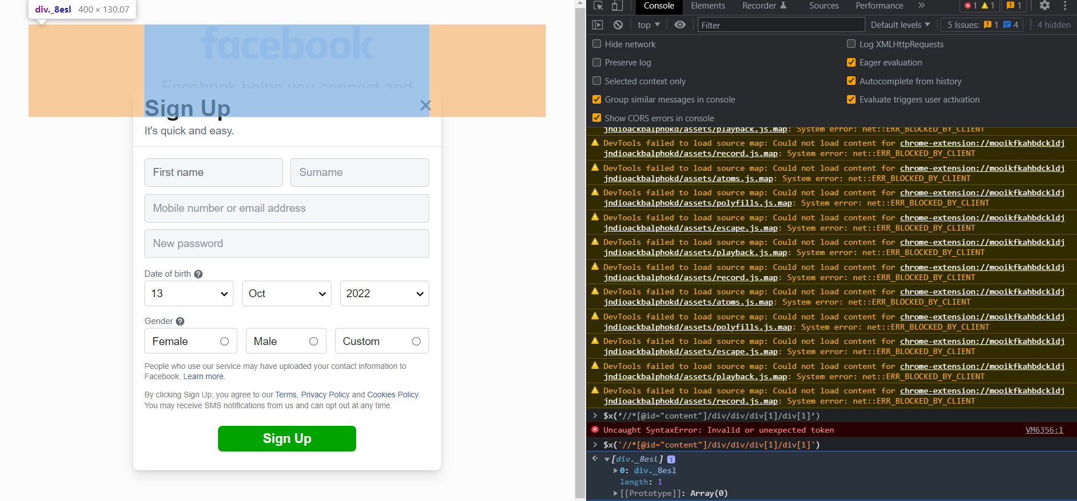

# Result:

Thus, identifying Web elements using Id, Name and XPath using Selenium IDE has been completed successfully.

**Evaluator’s Observation**

**Marks Secured: out of**

**Full Name of the Evaluator: Student’s Signature**

**Signature of the Evaluator: Date of Evaluation:**

# Task 11:

**Aim:** To use CSS selectors for identifying Web elements for selenium scripts using Selenium IDE.

# Procedure:

**Steps:**

# Using Tag and ID:

1. Hover on Email or Phone text box field to get its details and copy its ID field from the code.

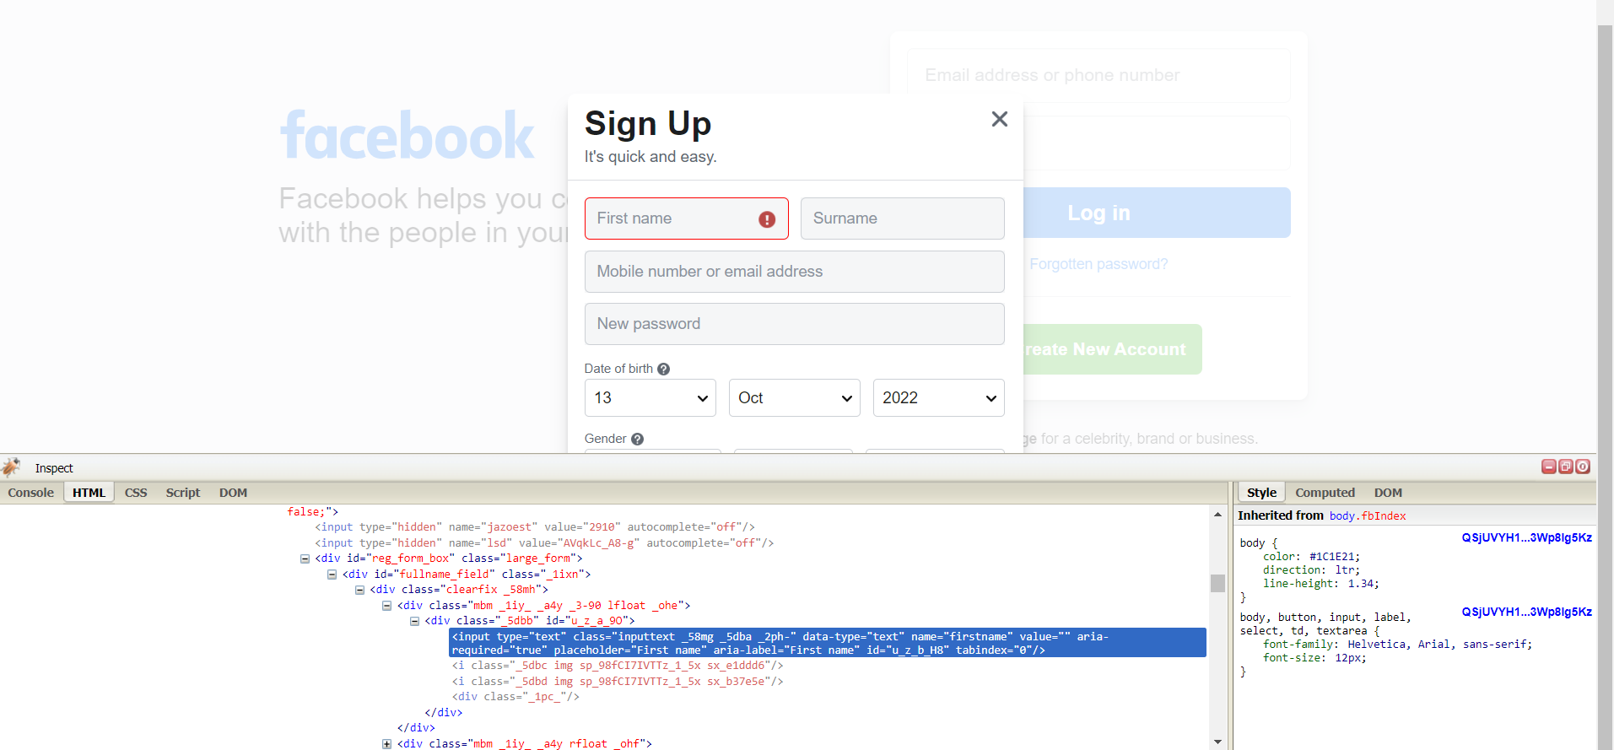

1. Click on selenium and click record a new test in a new project.

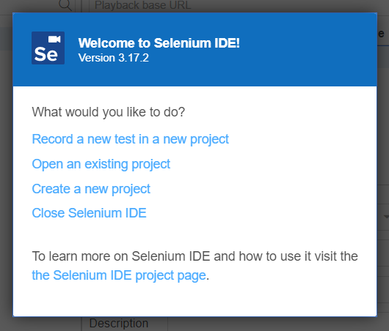

1. Name your project Give Facebook home page URL and click Start Recording.

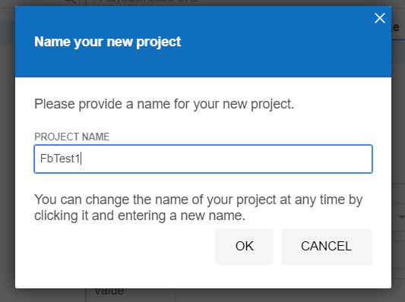

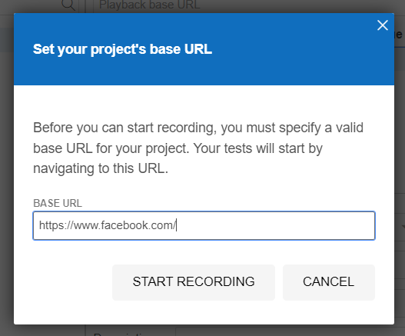

1. Selenium opens the given url and starts recording the action you will be performing in that page.

(Note: Don’t close that facebook page opened by selenium IDE) Now minimize Facebook page.

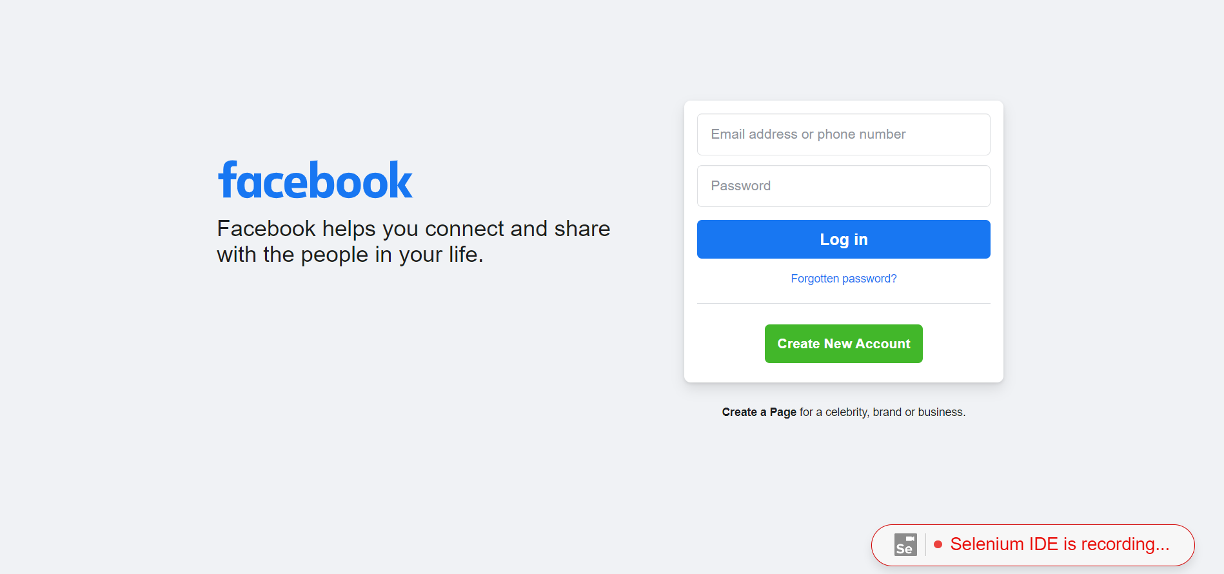

1. Click stop recording Give Test Name and click OK.

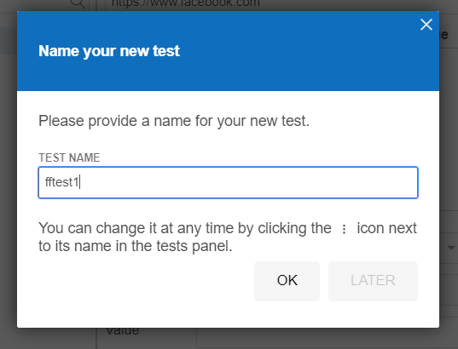

1. In command field, give **verify element present** and in target give **css=input#email**. (Note: **email** is the ID value for email field present in facebook login page which was copied before. And **input** is tag name).

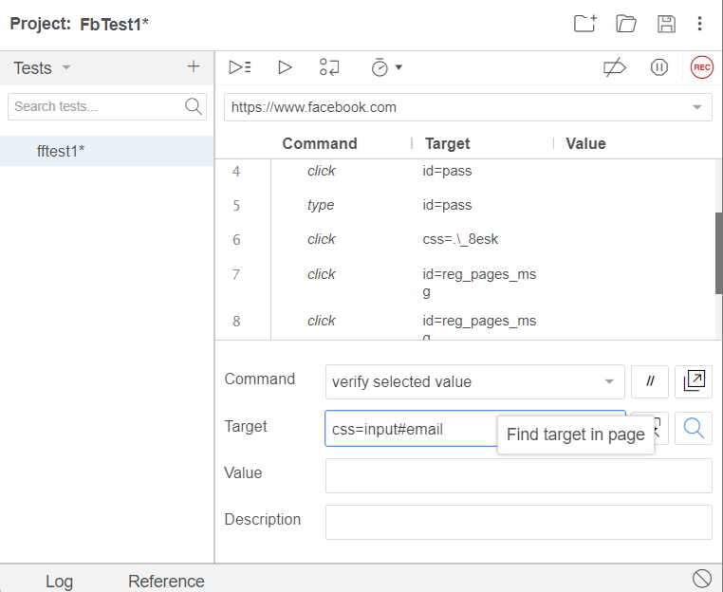

1. Now click on search button beside target field. Now, email field will blink.

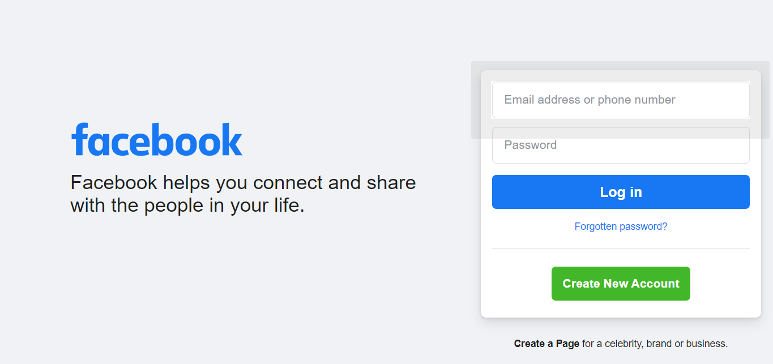

# Using Tag and Class:

i. Now inspect and copy **class** field value for Email or Phone field.

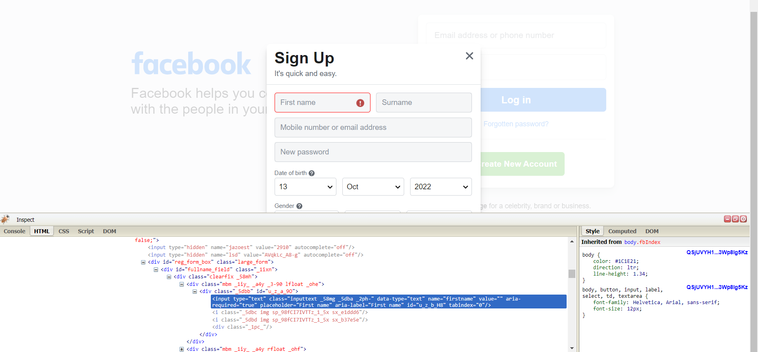

1. In command field, give **verify element present** and in target give

# css=input.inputtext.

1. (Note: **inputtext**is the class value for email field present in facebook home page which was copied before. And **input** is the tag name).

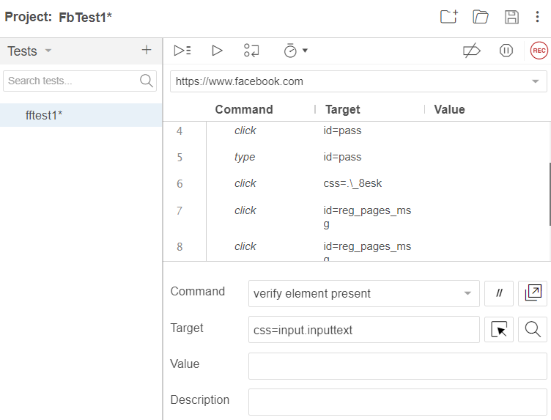

1. Now click on search button beside target field. Now, email field will blink.

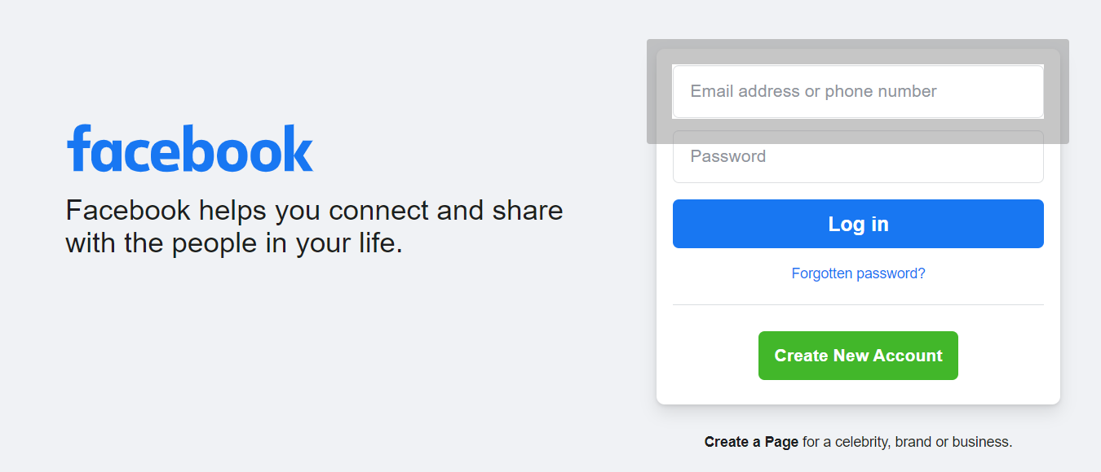

# Result:

Thus, using CSS selectors for identifying Web elements for selenium scripts using Selenium IDE has been completed.

**Evaluator’s Observation**

**Marks Secured: out of**

**Full Name of the Evaluator: Student’s Signature**

**Signature of the Evaluator: Date of Evaluation:**